

CSM3023 WEB BASEDAPPLICATIONDEVELOPMENT (K1)

**BACHELOR OF COMPUTER SCIENCE (MOBILE COMPUTING) WITH HONORS**

**SEMESTER 2 2023/2024**

LAB 4 – JSP: Scriptlet, Expression &Standard Actions

**Prepared by:**

ARIF AFIFY BIN SULAIMAN(S67610)

Task 1:

Coding: customer.html

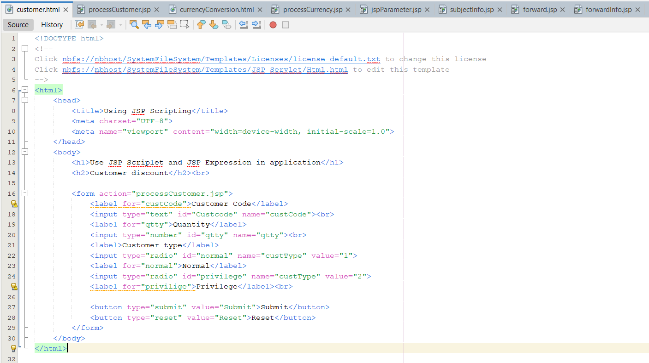

processCustomer.html

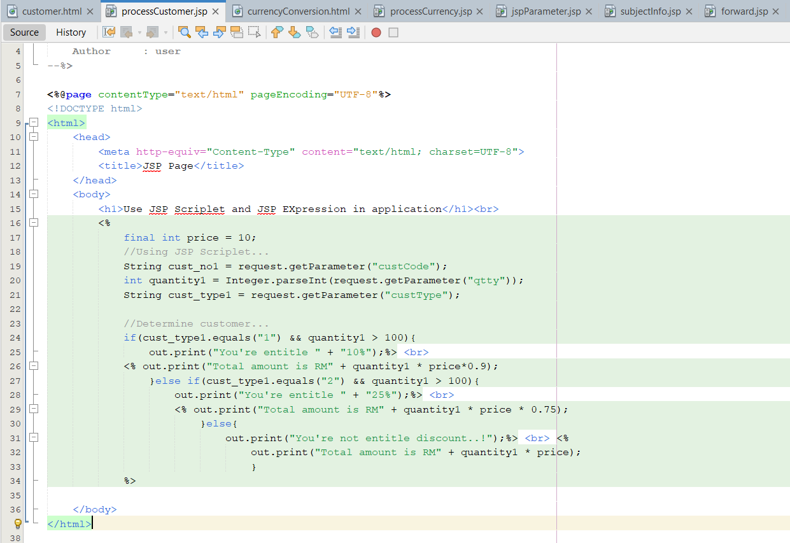

Output:

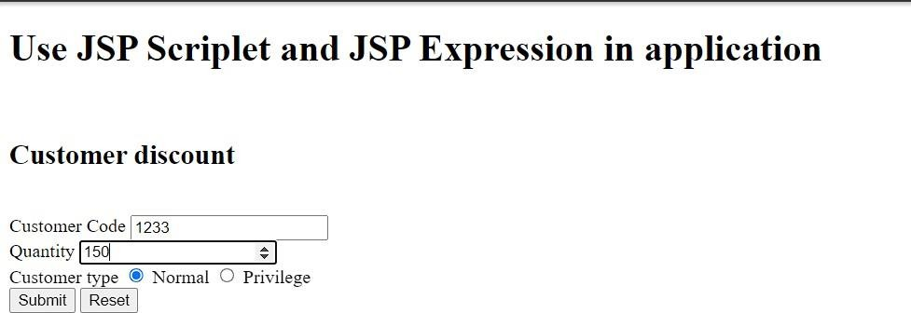

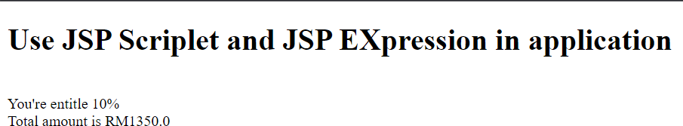

Reflection

1. What you have learnt from this exercise?

I have learnt how to apply JSP scriplet and expression in web application.

1. Explain three (3) type of JSP scripting? JSP declaration, expression and scriplet.

Task 2:

Coding: currencyConversion.jsp

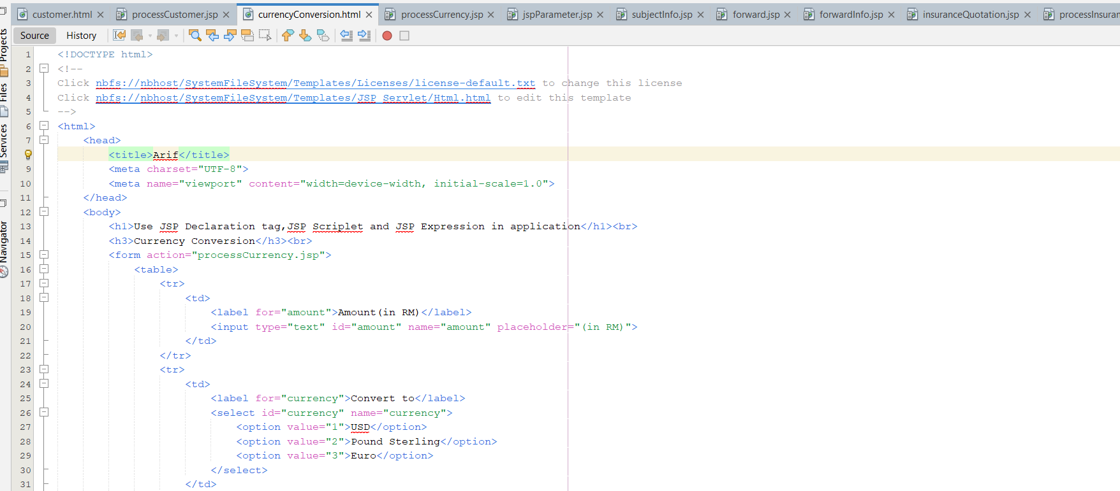

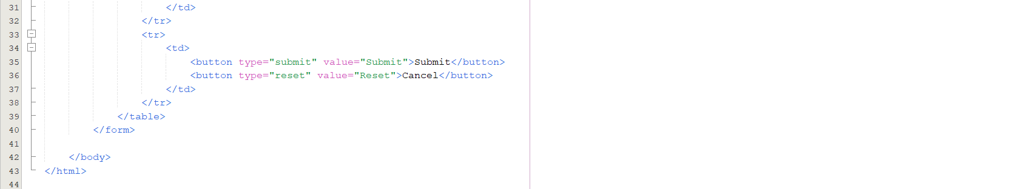

processCurrency.jsp

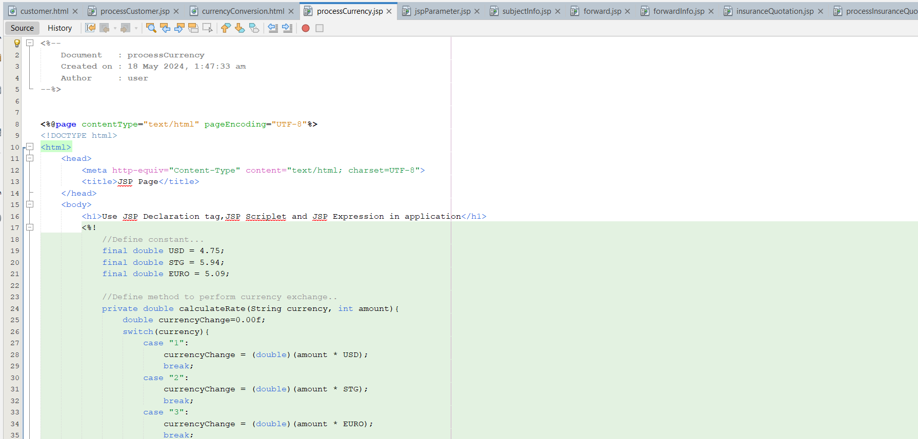

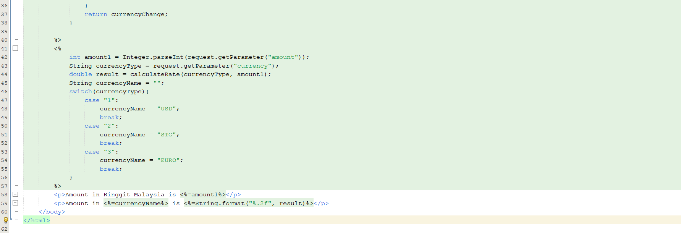

Output:

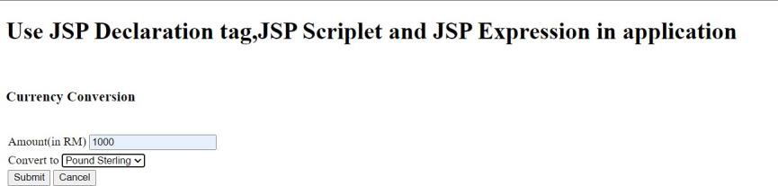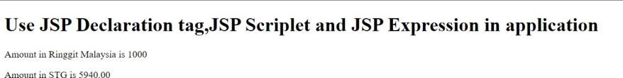

Reflection

1. What have you learn from this exercise?

I have learnt how to us JSP declaration tag to declare variable and function, JSP Expression and JSP Scriplet.

Task 3: Coding: jspParam.jsp

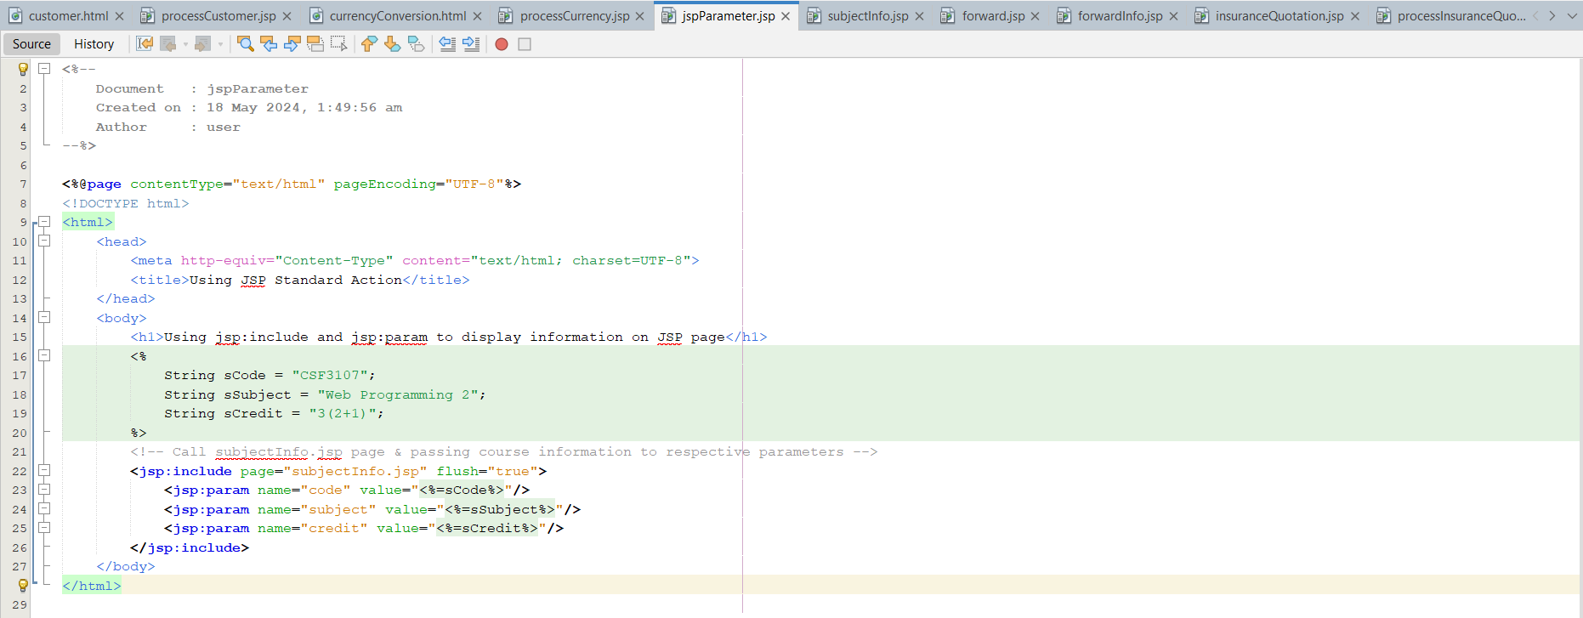

subjectInfo.jsp

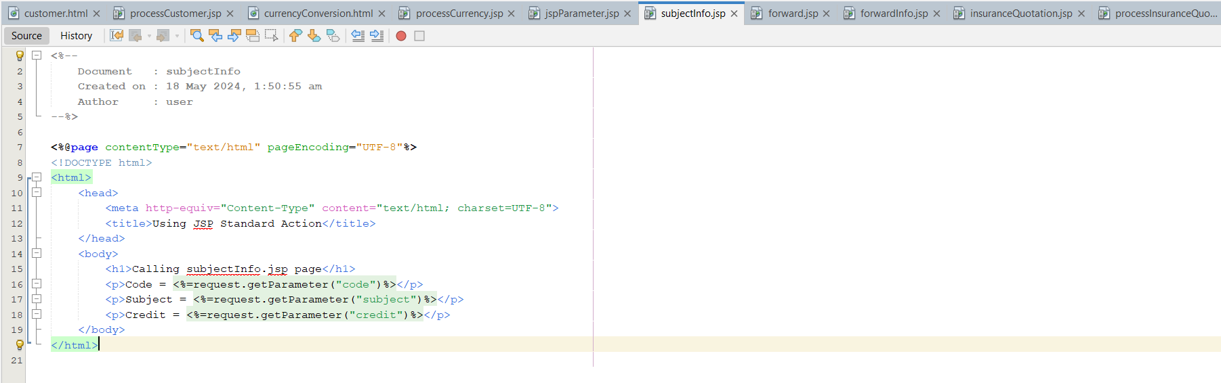

Output:

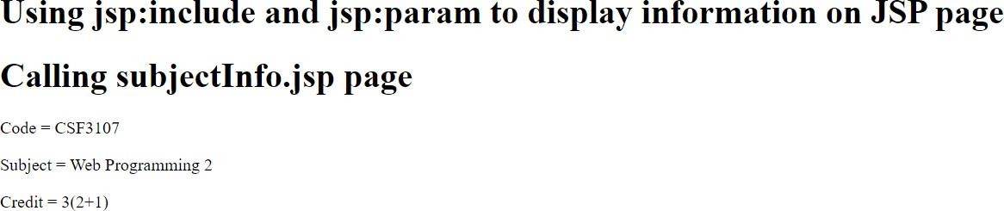

Reflection

1. What you have learnt from this exercise?

I have learnt how to use jsp:include to call method than pass information using jsp:param.

1. List TWO (2) other JSP Standard Action Tag jsp:forward & jsp:useBean

Task 4: Coding: forward.jsp

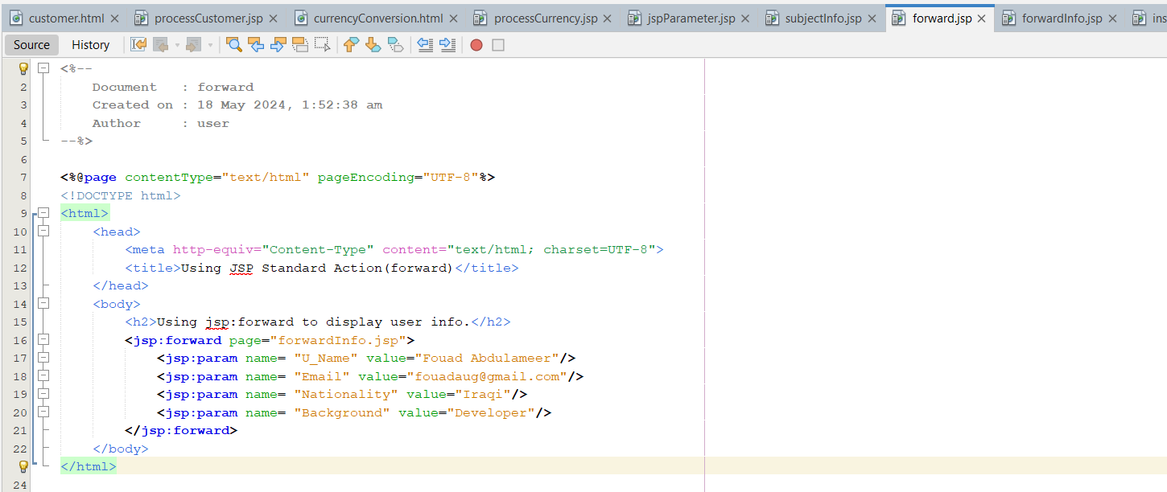

forwardInfo.jsp

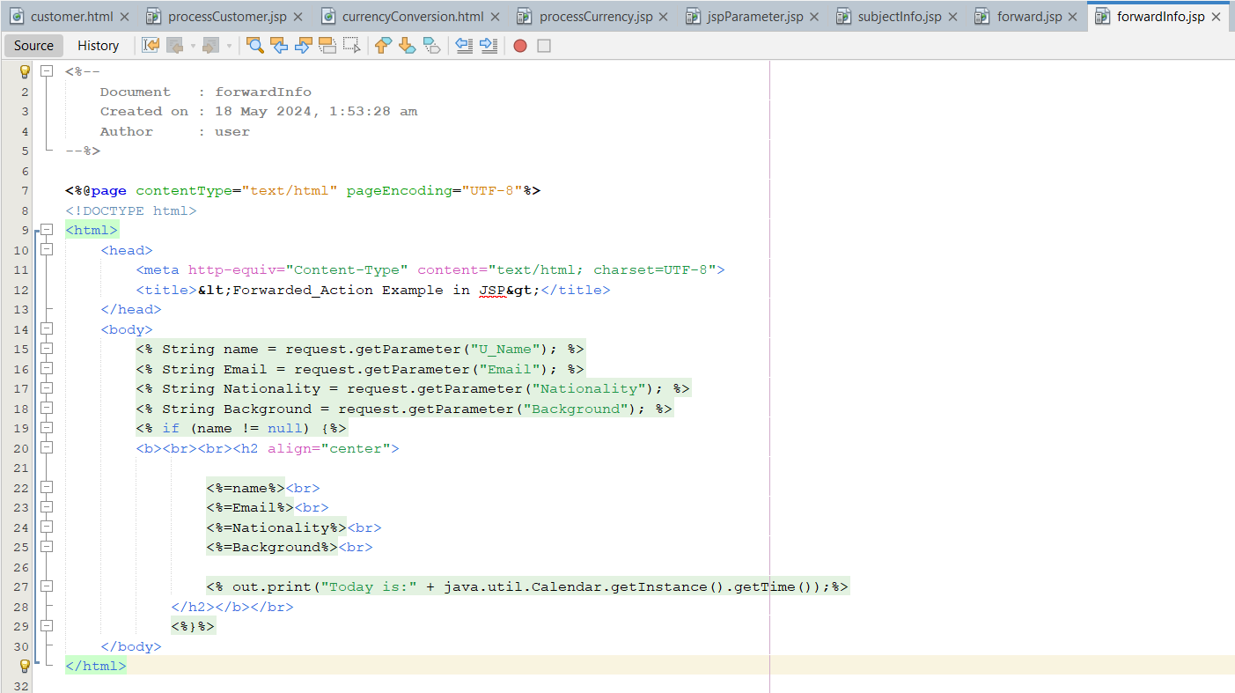

Output:

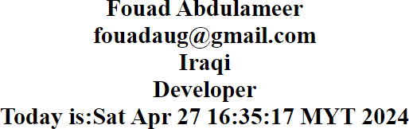

Reflection

1. What you have learnt from this exercise?

I have learnt how to use JSP Standard Action Tag JSP:forward to call targeted method than use JSP:param to forward information.

1. List TWO(2) More JSP Standard Action Tag
   1. jspsetProperty 2.jspgetProperty

Task 5:

Coding: insuranceQuotation.jsp

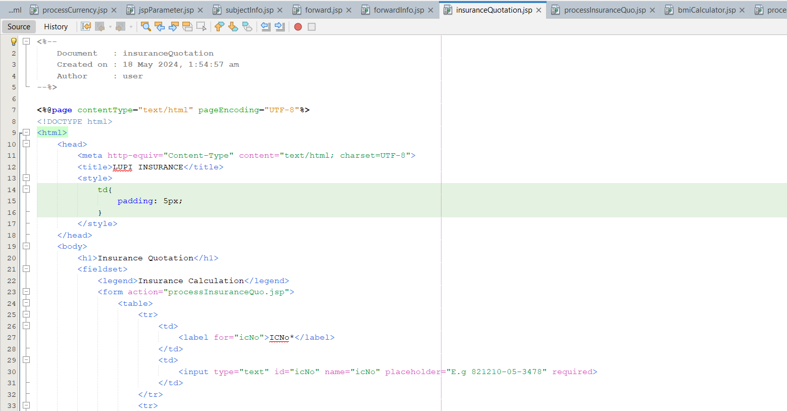

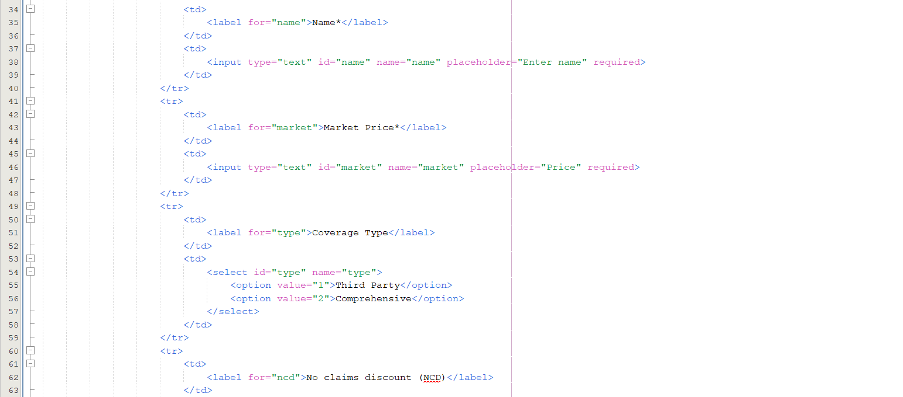

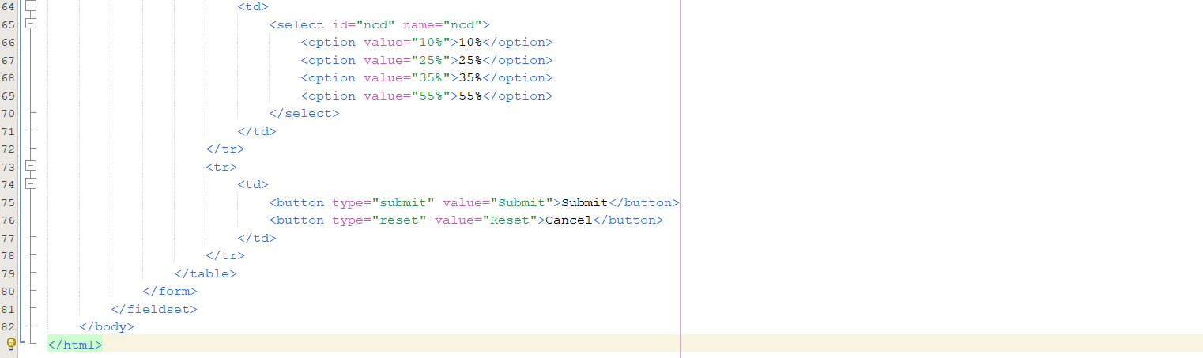

processInsuranceQuo.jsp

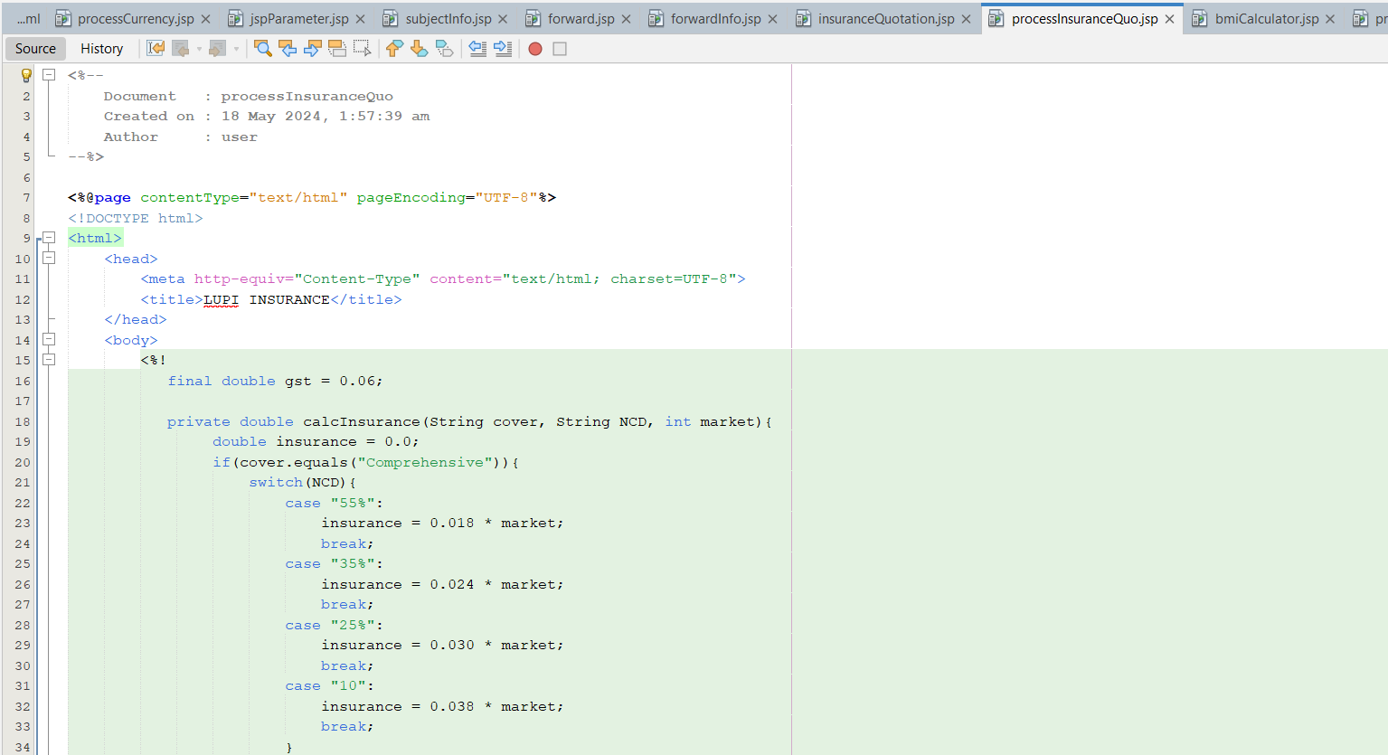

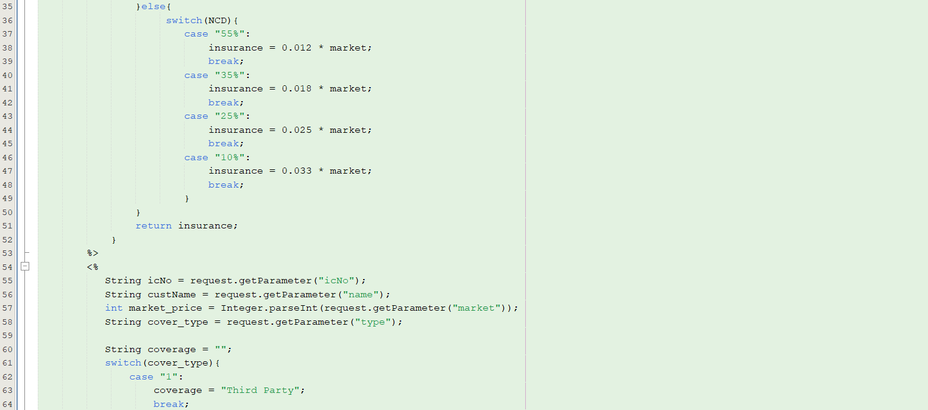

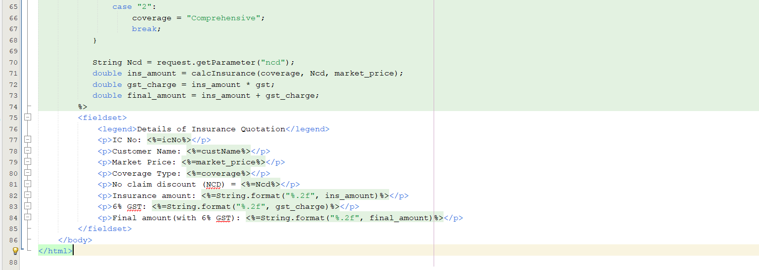

Output :

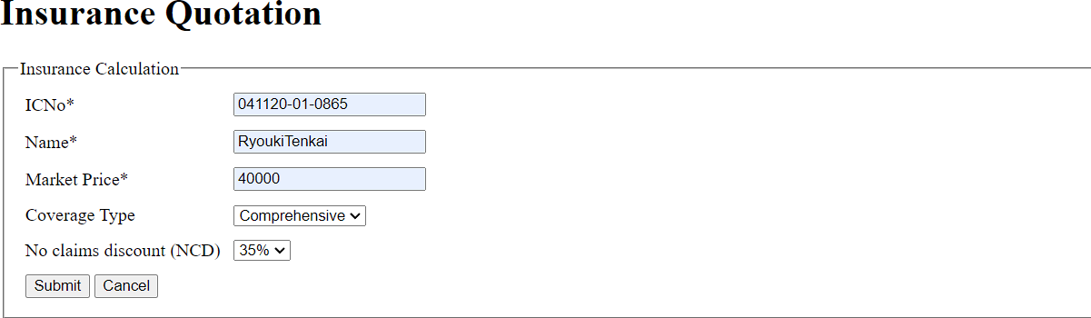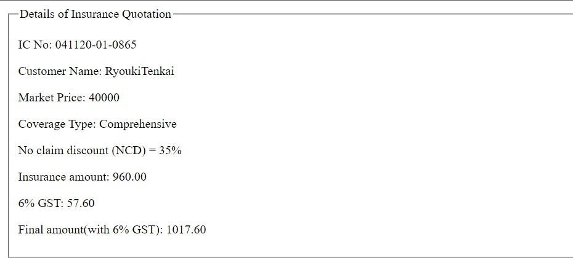

Reflection

1. What you have learnt from this exercise? I have learnt how to use Java Scriplet.
2. List all Java features you used in Java Scriptlet. Variable, data type, operator and controlstatement.

Exercise:

Coding

bmiCalculator.jsp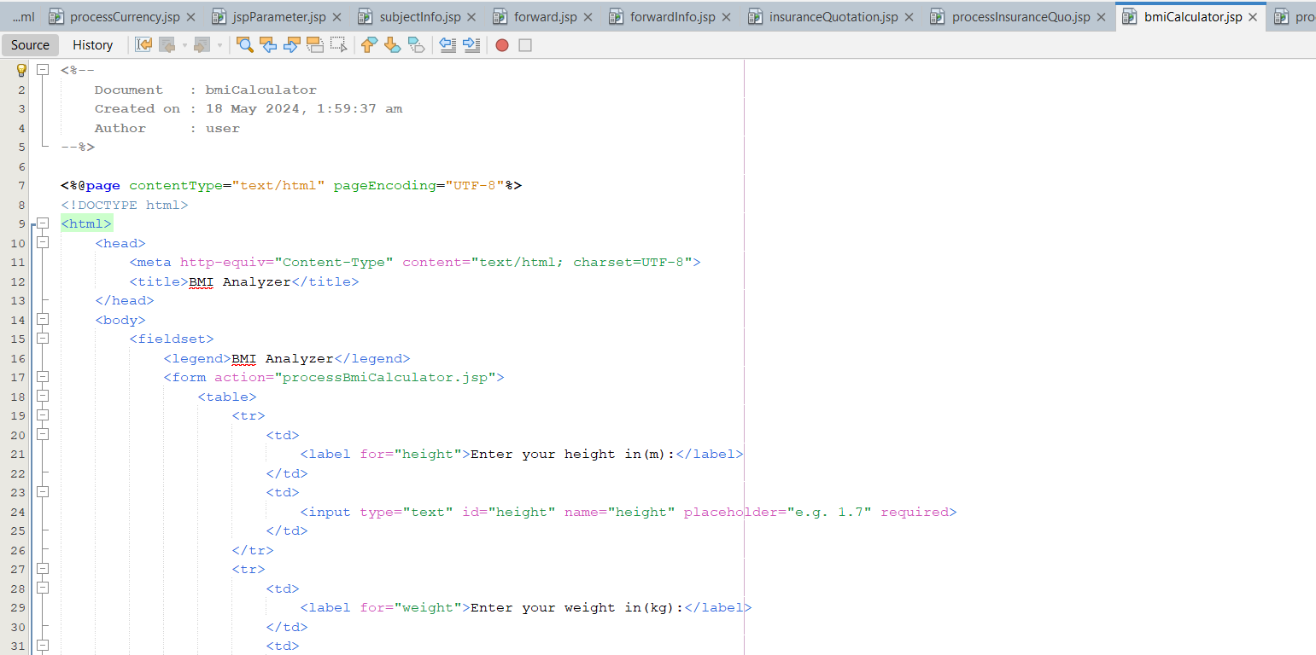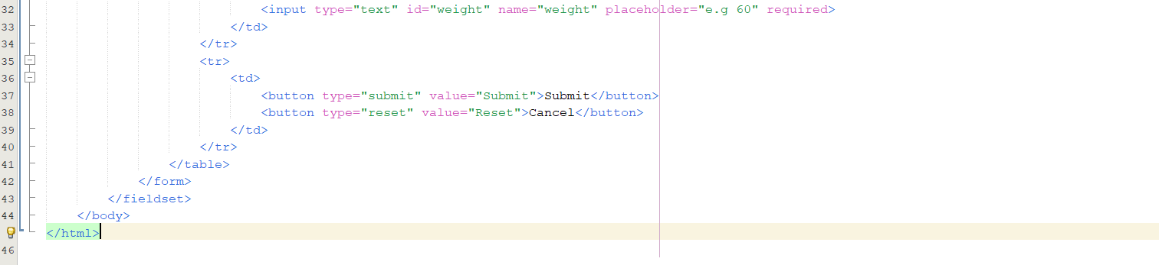

processBmiCalculator.jsp

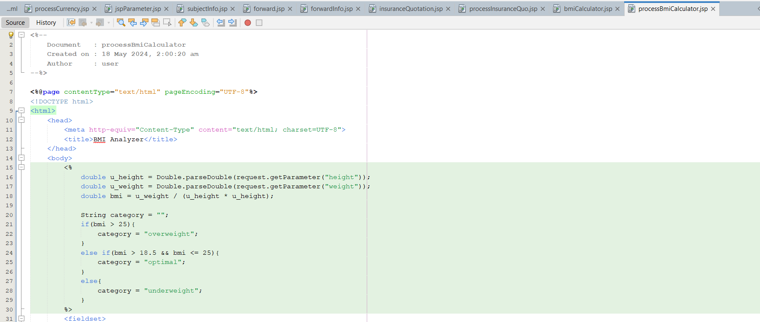

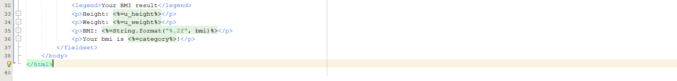

Output:

